Restriction on master Branch:-

Click on branches.

Click on three dots and then click on branch policies.

And ON the option(**Require a minimum number of reviewers).** Screenshot attach below.

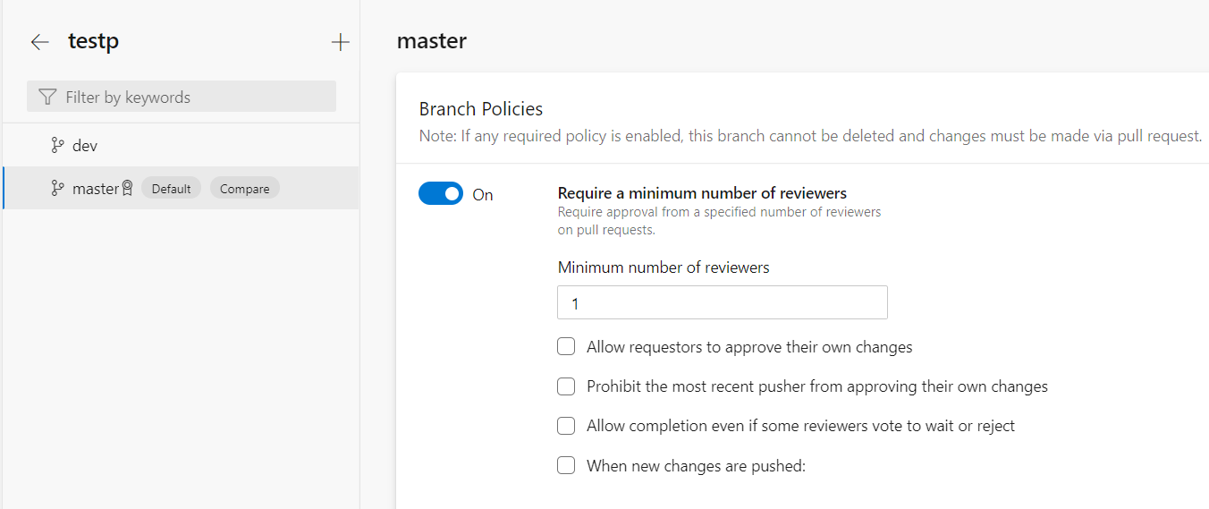

If we bypass the admin and other user then Go to branch Security and select the user. And Allow the option (Bypass policies when pushing). Refers the Screenshot attach below.

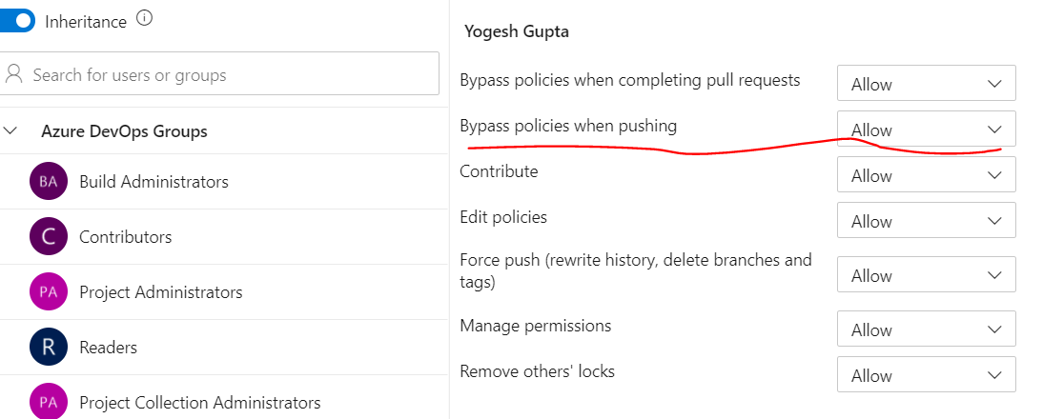

Restriction on merge on pull request.

Go to Master Branch and then click on branch security.

And select user and Deny the option(Contribute).

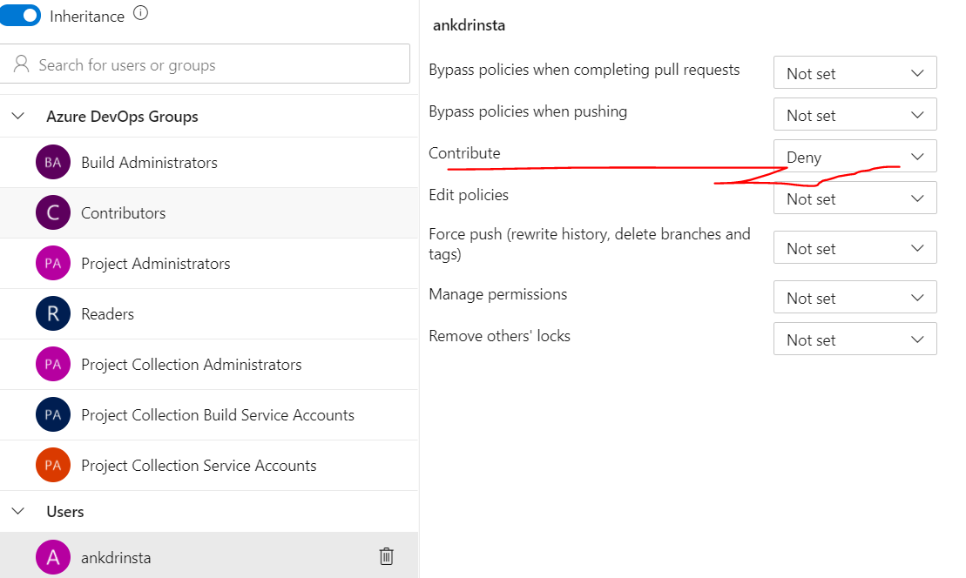

Creating user Organization level:-

For creating user go to organization setting and then click on user.

Then Click on option(add user).

